
PRESS RELEASE Ostrava, 1st August 2017

Nová Karolina Park has a ZOOT Try&Buy stores

Today Nová Karolina Park, an office building from the leading Czech developer and investment company, PASSERINVEST GROUP, welcomed Ostrava’s first Try&Buy stores from the ZOOT
e-shop among its retail tenants. ZOOT had the grand opening of its branch, with an area of 87 m², in the courtyard passage of the northern part of the building. Thus Ostrava’s fashionistas will be able to simply and comfortably try out the items they order and only take home those that really fit. There will also be a beauty salon and nail studio opening here in the near future. Thus all of the retail units in Nová Karolina Park are currently fully leased.

“We chose the locality of the new ZOOT outlet because of its unique position in the centre of an agglomeration of a million inhabitants. Nová Karolina Park is next to the historical centre and
a shopping centre and close to the bus and train stations and in the vicinity of the cultural life in Ostrava. Nová Karolina Park is architecturally interesting, has an impressive design and a beautiful atrium with a water fountain. It is a place that people like coming to. We wanted to be here, too, so that we could close at hand for our customers and in a pleasant place. The negotiations with PASSERINVEST GROUP were also excellent for us, as they were willing and accommodating,” commented Jana Zbořilová, the Expansion Manager of Zoot a.s.
Nová Karolina Park connects Ostrava’s historical centre with the city’s modern areas. It is situated in
a strategic site on Ostrava’s main 28. října Street with a tram stop right in front of the building.
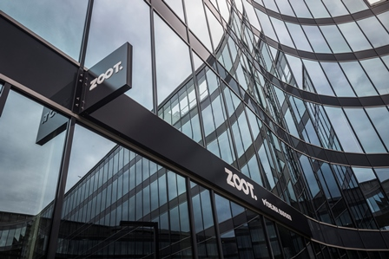

Ostrava’s first ZOOT Try&Buy stores in Nová Karolina Park

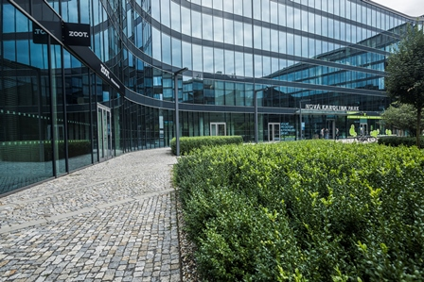

Ostrava’s first ZOOT Try&Buy stores in Nová Karolina Park

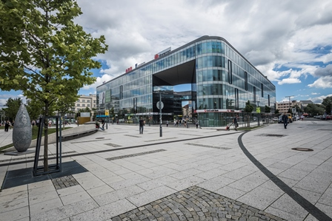

Nová Karolina Park

ABOUT THE NOVÁ KAROLINA PARK PROJECT
The Nová Karolina Park office building is sensitively located in a newly-urbanised area of Ostrava near Masarykovo náměstí and it forms a “gateway” from the historic core of the city. The developer of the project is a joint venture between PASSERINVEST GROUP and GEMO OLOMOUC. The project’s architectural design comes from the drawing boards of Vít Máslo and David R. Chisholm of CMC architects. The entire project is spread out over 32 hectares of space on six storeys and it offers almost 24,600 m² of prime office space. This is supplemented on the ground floor with 3700 m² of space suitable for shops, services and restaurants. There are 279 underground parking spaces meant for the users of the building. Nová Karolina Park is certified as a green building according to BREEAM (BRE Environmental Assessment Method). The British BREEAM certificate is a prestigious methodology for the certification of green buildings in Europe.

PASSERINVEST GROUP, a. s., is a purely Czech development company, whose name is primarily connected with the construction of the multifunctional BB Centrum complex in Prague 4 – Michle. The company, founded in 1991 by Radim Passer, built a very good name on both a domestic and international level with this, the most successful and extensive Czech project of its kind. This is not only due to the quality of the implemented projects and the high level of provided services, but also to a sense of fair play, an accommodating relationship with the tenants/users of the buildings and the responsibility towards society and the environment. PASSERINVEST GROUP also has other interesting development projects in its portfolio.

For more information and photographs in print quality please contact:
Kristýna Samková, Head of PR and Marketing dept.
PASSERINVEST GROUP, a.s.
Tel.: (+420) 221 582 111
Mobil: (+420) 602 186 708
E-mail: Kristyna.Samkova@Passerinvest.cz
www.passerinvest.cz, www.bbcentrum.cz

Marcela Štefcová
Crest Communications a.s.
Mobile: (+420) 731 613 669
E-mail: marcela.stefcova@crestcom.cz
www.crestcom.cz

